GEAZAN 6-Channel Interactive
Digital Audio Processor
(Model No.: RC0606E-U)

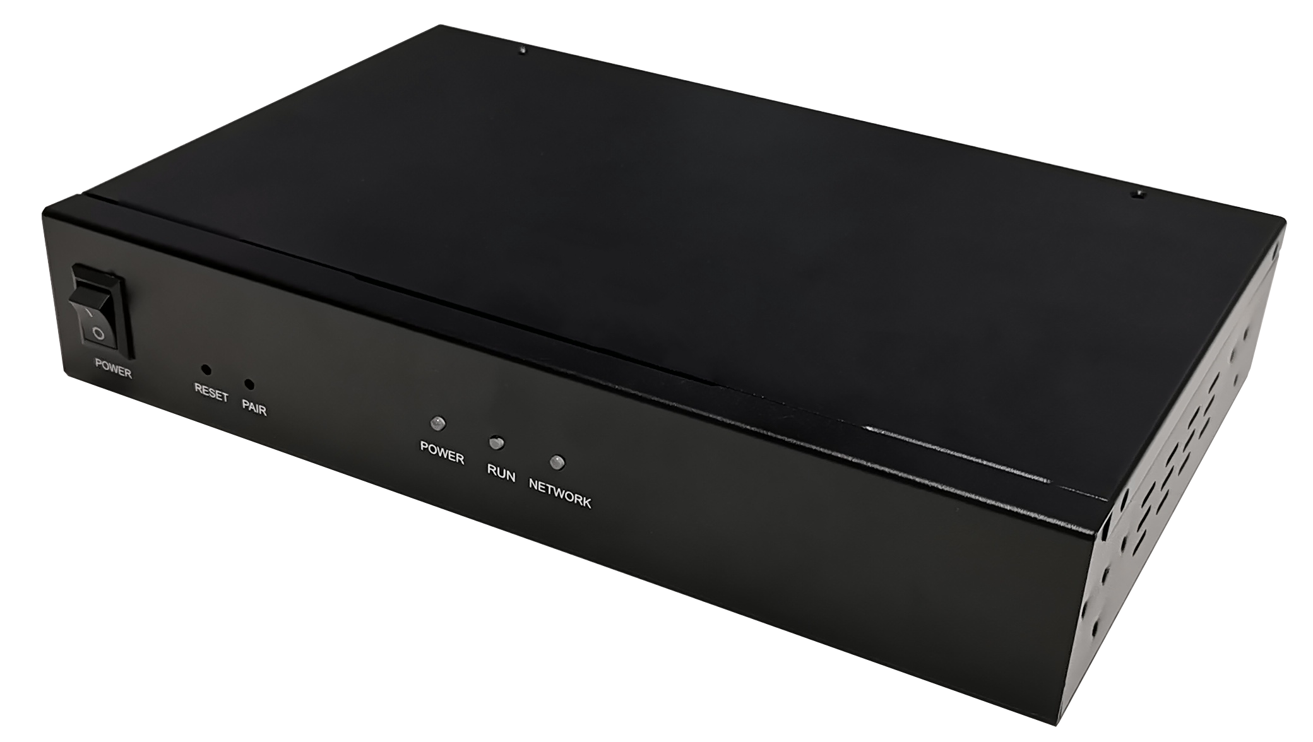

Overview
RC0606E-U is a compact 6-channel interactive digital audio processor designed by GEAZAN. The unit provides 2 Microphone inputs, 4 Line inputs, 6 Line outputs, 1 wireless microphone input, and 1 USB 2.0 A interface. It adopts adaptive echo cancellation, adaptive dereverberation, adaptive noise reduction, and smart mixing technology and has an extremely high SNR reproducing a clear and natural sound. RC0606E-U is equipped with GEAZAN's exquisite and compact spherical omnidirectional microphone, the system perfectly picks up the sound and cancels echoes in a room size of 100m2.
According to the design ideas of GEAZAN’s smart, configuration-free and simple to use, RC0606E-U adopts adaptive algorithm and is ready to use after installation. It is convenient for engineers to install and debug, and also meets the needs of normalized interaction and audio collection of recording system.

Highlights
- More than 5m radius pick-up sounds each mic, cover full classroom in 2 mics
- Suitable for normalized recording and playback classrooms or conference rooms with interactive needs.
- Easy installation, reduced project deployment time.
- 1 USB audio interface can be integrated into the computer as a sound card.
- Visual control software simplifies panel operation.

Features
- 2 Balanced mic inputs, support 48V phantom power supply, phoenix connector.
- 4 Balanced line inputs, phoenix connector.
- 6 Balanced line outputs, phoenix connector.
- 1 Wireless microphone interface, 3.5mm connector.
- 1 Monitor headphone interface, 3.5mm connector.
- 1 USB2.0 A interface, supports bidirectional audio data transmission.
- 1 RS232 serial port, which can be connected to the control terminal.
- 1 RJ45 interface, which can be connected to the configuration computer.
- 1 RESET key to restore the default factory settings.

Connection and Usage
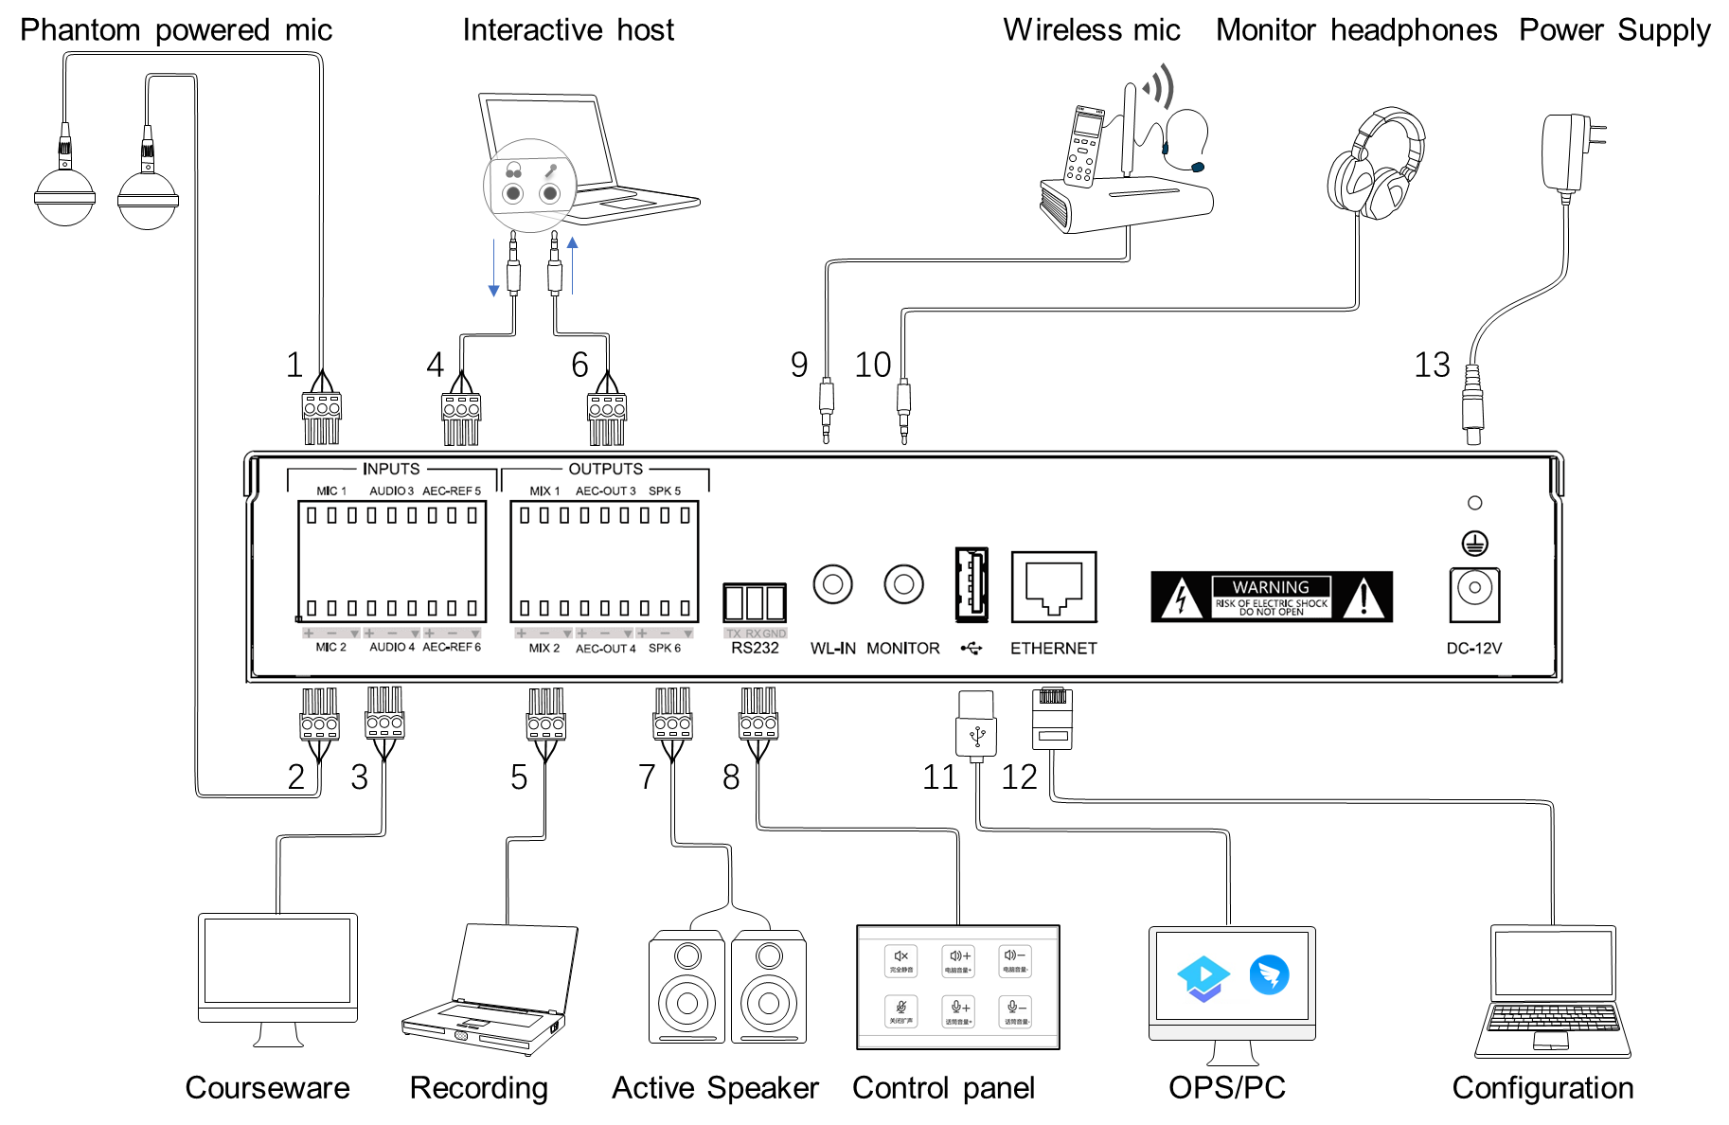

Devices will be connected through the interfaces in the rear panel, details are below:
1-2. MIC: Two balanced microphone input interfaces, supporting 48V phantom power supply, suitable for accessing omni-directional and directional microphone.
3. AUDIO: Line input interfaces. It can be connected to local sound source input, such as DVD, computer, etc.
4. AEC-REF: Line input interfaces. It can access the signal from the remote end in interactive and distance teaching, that is, reference signal input.
5. MIX: Line output interfaces. It can be connected to external recording equipment.
6. AEC-OUT: Line output interfaces. The processed audio signal is output to the far end.
7. SPK: Line output interfaces. It can be connected to an external power amplifier or an active speaker.
8. RS232: Serial control interface. It can be connected to the external control terminal.
9. WL-IN: 3.5mm wireless microphone input interface. It can be connected to a wireless microphone.
10. MONITOR: 3.5mm monitor headphone interface. It can be connected to a monitor headphone.
11. USB2.0 type A interface: It supports bidirectional audio data transmission.
12. ETHERNET: RJ45 interface. It can be connected to the configuration computer.
13. Power interface: DC-12V.

Appearance and Interfaces
Front
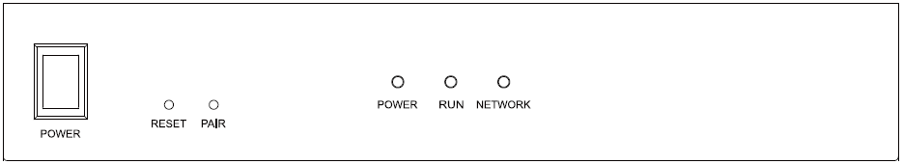

Instructions for Front Panel
Interface, Indicator and Knobs | Function Description
POWER key | Power switch
RESET | Restore the factory configuration key. Long press 3s to restart the device and restore the factory configuration.
PAIR | Reserved function key.
POWER indicator | The power indicator remains on after power on.
RUN indicator | The operation indicator flashes slowly, indicating normal operation.
NETWORK indicator | Network connection indicator, always on when network and PC control terminal connection is established

Rear
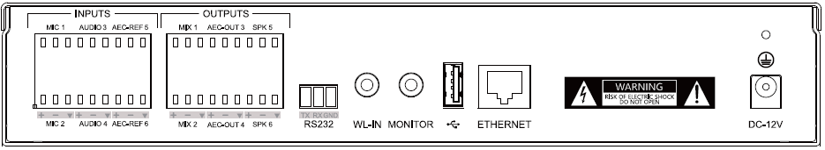

Instructions for Rear Panel
Interface, Indicator and Knobs | Function Description
MIC (1-2) | 2 balanced microphone input interfaces, supporting 48V phantom power supply.
AUDIO (3-4) | 2 (left and right channel) line input interfaces, for the local audio source, such as DVD, computer, etc.
AEC-REF (5-6) | 2 (left and right channel) line input interfaces to access the signal from the remote end in interactive and distance teaching.
MIX (1-2) | 2 (left and right channel) line output interfaces, external recording equipment can be connected.
AEC-OUT (3-4) | 2 (left and right channel) line output interfaces to output the processed audio signal to the far end.
SPK (5-6) | 2 (left and right channel) line output interfaces, which can be connected to power amplifier or active speaker for local sound reinforcement output.
RS232 | The serial control interface, can be connected to the control terminal.
WL-IN | 3.5mm wireless microphone input interface.
MONITOR | 3.5mm monitor headphone interface.
USB2.0 type A interface | Support bidirectional audio data transmission.
Ethernet | RJ45 interface to PC for configuration.
Power interface | DC-12V.

Specifications
Parameter | Value
Frequency Response (20Hz~16kHz @ +4dBu):
Microphone Channel | +0/-2dB
Line Input Channel | +0/-0.5dB
THD +N (1kHz @ +4dBu):
Microphone Channel | < 0.009%
Line Input Channel | < 0.007%
Equivalent Noise | < -84dBu(20Hz~16kHz@22dB)
Dynamic Range | > 105dB(20Hz~16kHz@0dB)
Maximum Input Balance
Microphone Channel | -2dBu
Line Input Channel | 20dBu
Maximum Output Balance | 20dBu
Maximum Gain
Microphone Channel | 50dB
Line Input Channel | 0dB
Input Impedance
Microphone Channel | 2.2KΩ
Line Input Channel | 20KΩ
Output Impedance | 400Ω
Sampling Frequency | 32kHz
A/D-D/A Converter | 24-bit
Phantom Power | DC 48V
Size | 250mm×165mm×45mm

